Summarise and attack
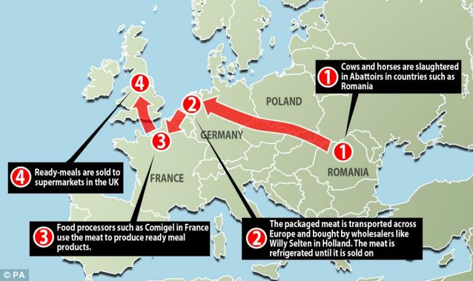
Horse meat map

Number these summary statements in the order in which they appear in the article:

- The source of the horsemeat is still under investigation by the relevant authorities.

- Experts say horsemeat itself should be no more dangerous than beef to eat.

- Environment Secretary Owen Paterson: "This appears to be an issue of fraud and mislabelling.”
- A third of people in the UK who responded to a poll on Monday on their shopping habits said they were less likely to buy processed meat as a result of horsemeat scandal.
- Romania has rejected claims that it was responsible for wrongly describing horsemeat from its abattoirs as beef.

- The Food Standards Agency (FSA) has ordered food businesses to check for horsemeat in all processed beef products, such as beef burgers, meatballs and lasagne.

Summarise and attack
Complete the table below.
Which companies are named in the article?  Introduction | ……………………………………………………  ……………………………………………………  ……………………………………………………  ……………………………………………………
Which countries are involved in / affected by the scandal?  Introduction | ……………………………………………………  ……………………………………………………  ……………………………………………………  ……………………………………………………
Which foods were affected?  Introduction | ……………………………………………………  ……………………………………………………  ……………………………………………………  ……………………………………………………
What action did various retailers take?  Findings | ……………………………………………………  ……………………………………………………  ……………………………………………………  ……………………………………………………
What did the experts say about the safety of eating horse products?  Findings | ……………………………………………………  ……………………………………………………  ……………………………………………………  ……………………………………………………
Did the scandal affect consumer confidence?  Findings | ……………………………………………………  ……………………………………………………  ……………………………………………………  ……………………………………………………
What could be done to prevent a similar situation in the future?  Conclusion | ……………………………………………………  ……………………………………………………  ……………………………………………………  ……………………………………………………

Write a report
Using the information you have gathered write a report about the horsemeat scandal.
You will need to include information about:
- What the scandal was about and its possible causes.
- What action was taken?
- What could be done to prevent this happening again?

Report Format
The title – Main heading. This tells you what the report is about.
Introduction- 1st sub-heading. Use this section to describe what the report is about, what it hopes to achieve and where you have taken your information from.
Findings – 2nd sub-heading. Use this section to compare the issues or advantages/disadvantages of your information. You can use bullet points in this section.
Conclusion / Recommendations – 3rd sub-heading. Use this section to describe the results of your findings. Which service / option / course of action is best? You must always give a reason for your decision. Then recommend what the reader of your report should do next.

