Two-Way Tables GREEN

- In a supermarket survey, 30 men and 30 women were asked whether they preferred orange juice or grapefruit juice. 22 men preferred orange juice. 12 women preferred grapefruit juice. How many people liked orange juice best?

- A factory employs 12 supervisors, of which 2 are female; 14 office staff, of which 3 are male; and 120 shop floor workers, of which 38 are female.
  - How many male employees are there?
  - Write down the total number of employees.

- A number of men and women were asked which type of crisps they liked best. A total of twelve people said Plain, of which seven were men. Six women liked Salt and Vinegar. Fourteen men and twelve women like Cheese and Onion. There were 28 men in total.
  - How many people liked Salt and Vinegar crisps best?
  - How many people were asked altogether?

- 159 boys and girls were asked about what their favourite subjects were. Out of a total of 78 girls, 28 said that their favourite subject was science. Altogether, 41 students said their favourite subject was science, with 52 saying maths. 30 girls said PE was their favourite.
  - How many boys said PE was their favourite?
  - How many boys said maths was their favourite?

Two-Way Tables AMBER

- In a supermarket survey, 30 men and 30 women were asked whether they preferred orange juice or grapefruit juice. 22 men preferred orange juice. 12 women preferred grapefruit juice. How many people liked orange juice best?
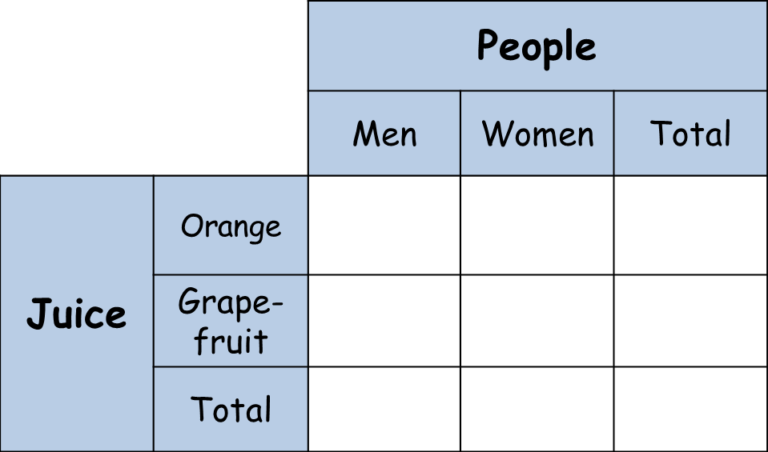

- A factory employs 12 supervisors, of which 2 are female; 14 office staff, of which 3 are male; and 120 shop floor workers, of which 38 are female.
  - How many male employees are there?
  - Write down the total number of employees.

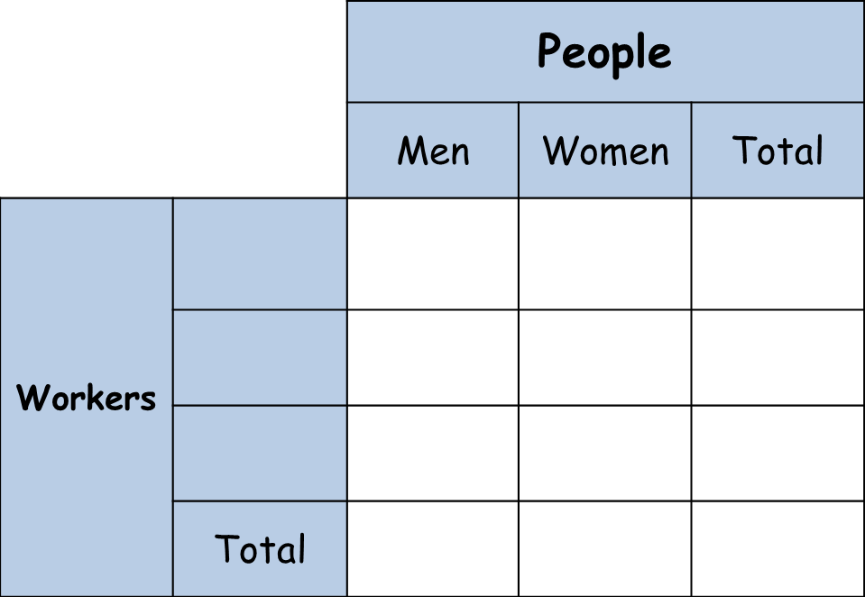

- A number of men and women were asked which type of crisps they liked best. A total of twelve people said Plain, of which seven were men. Six women liked Salt and Vinegar. Fourteen men and twelve women like Cheese and Onion. There were 28 men in total.
  - How many people liked Salt and Vinegar crisps best?
  - How many people were asked altogether?

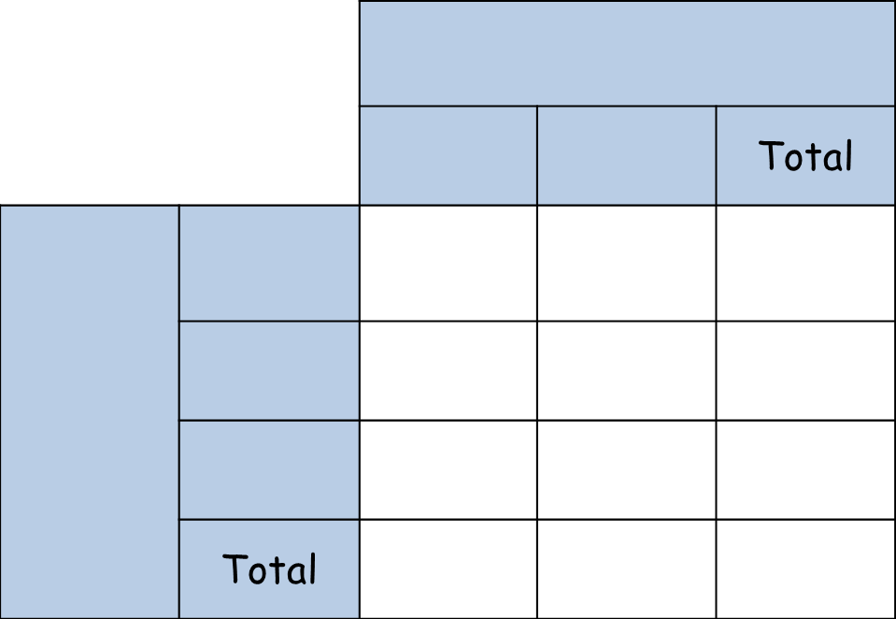

- 159 boys and girls were asked about what their favourite subjects were. Out of a total of 78 girls, 28 said that their favourite subject was science. Altogether, 41 students said their favourite subject was science, with 52 saying maths. 30 girls said PE was their favourite.
  - How many boys said PE was their favourite?
  - How many boys said maths was their favourite?

Two-Way Tables RED

- In a supermarket survey, 30 men and 30 women were asked whether they preferred orange juice or grapefruit juice. 22 men preferred orange juice. 12 women preferred grapefruit juice. How many people liked orange juice best?
12
22
30
30

- A factory employs 12 supervisors, of which 2 are female; 14 office staff, of which 3 are male; and 120 shop floor workers, of which 38 are female.
  - How many male employees are there?
  - Write down the total number of employees.

- A number of men and women were asked which type of crisps they liked best. A total of twelve people said Plain, of which seven were men. Six women liked Salt and Vinegar. Fourteen men and twelve women like Cheese and Onion. There were 28 men in total.
  - How many people liked Salt and Vinegar crisps best?
  - How many people were asked altogether?

- 159 boys and girls were asked about what their favourite subjects were. Out of a total of 78 girls, 28 said that their favourite subject was science. Altogether, 41 students said their favourite subject was science, with 52 saying maths. 30 girls said PE was their favourite.
  - How many boys said PE was their favourite?
  - How many boys said maths was their favourite?

