Analysing an opinion article
Is Big Burger still big enough? by Tom Wilson
During its three decades in business Big Burger has maintained its position as a leading fast food chain, outranked only by sizzling rivals, Burger Max and Tasty Burger.
First, let's talk about the positive aspects of Big Burger's menu. The sandwiches – as burger chains insist on calling them – are big and scrumptious, as are the sauces that slosh inside them.
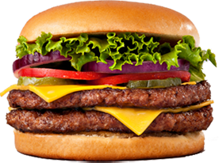
The flame grilled burgers are even better. One dribbly bite leads to the next. Once you start, you just can’t stop.
Big Burger, however, is not without its weaknesses. Most notable is the nutritional content of its products. Quite frankly, Big Burger's fat and calorie levels should make even the most voluptuous junk-food lover have second thoughts about eating in one of their joints. Take their all-time favourite, the Big'un with Cheese. That delicacy throbs with nearly 789 calories and 45 grams of fat, placing it well above the competition's burgers. Personally that makes me feel sick and, if an early heart attack is on your wish list, then I’d go ahead and order the Double Big'un with Cheese.
This monstrous feast contains a staggering 1028 calories, 76 grams of fat, and 179 milligrams of cholesterol! Keep a paramedic handy for that one.
So what’s on offer if you're looking for low-fat fast food? Well, not much. The only item that is really low in calories and fat is the Chick'n Lick'n Sandwich – as long as you pass on the mayonnaise. Alternatively, you could order your Big'un without the cheese. This cuts the calories to 504 and the fat to 21 grams, which isn't too bad. However, I would not recommend ordering a Big'un without the cheese or mayonnaise. It really doesn't taste of much.
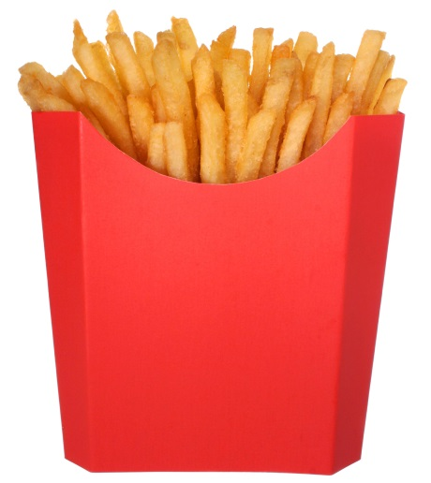
Variety isn't Big Burger's strong point either. The menu offers little beyond the standard fast food items (burgers, chicken sandwiches, fries, apple pies, etc). Big Burger really needs to spice up the menu by offering other types of food. If they want to compete with the really big boys – Burger Max and Tasty Burger – then they are going to have to offer more. At present it seems as if they're just stumbling in the footsteps of their rivals – about ten years behind.
Big Burger's fries are no better than OK either. I have also found that the quality of the fries varies greatly from one outlet to another: too crispy in Scunthorpe, too greasy in Bournemouth and they are bland everywhere. I recommend passing on the fries and ordering onion rings instead. I have always been satisfied with their onion rings.
It was Big Burger that always emphasised eating in. Prior to this, burger fans either had to munch and slobber in the street (probably in the rain!) or take the food home. The dining area is usually well looked after and some Big Burger restaurants have a 'play zone' for kids. Generally staff are friendly and all complaints are dealt with well. They really try to give customer satisfaction.
Sometimes they succeed.
In summary, Big Burger may be shrinking but its customers aren't. BB is still a pretty good fast food joint that will always satisfy your hunger – and provide a great incentive to get down the gym too.

Exam style question
How does Tom Wilson show his attitude towards Big Burger, its food and its customers?
Think about what he says and how he says it.

