1 Write down: i the next number and ii the term-to-term rule for sequences a and b.
a 23, 17, 11, ... b 2.4, 3.7, 5.0, ...
2 a Draw x- and y-axes from −4 to 4.
b Plot and label the points A(−3, 1), B(0, 4) and C(2, 2)
c ABCD is a rectangle. Mark point D on your diagram.
d Write down the coordinates of D.
3 John takes t minutes to cycle to school.
a It takes him three times as long to walk to school. Write down, in terms of t, how long it
takes him to walk to school.
b When John goes to school by bus, it takes him 10 minutes longer than when he cycles.
Write down, in terms of t, how long it takes him to go to school by bus.
c One week John cycles to school on two days and goes by bus on three days. Write down, in terms of t, the total time he spends travelling to school that week.
Simplify your answer as far as possible.
d If t = 14, use your answer to c find the total time that John spends travelling to school
that week.
4 The cost, in pounds, of hiring a cement mixer is worked out using the rule:
multiply the number of days by 6 and add 15
a Write the rule as a formula to find the cost, C, when the cement mixer is hired for n days.
b Use your formula to find the cost of hiring the cement mixer for 7 days.
c Geoff was charged £81 for the hire of the cement mixer. For how many days did he hire it?
5 Solve each of the following equations.
a 3x + 7 = 13 b = 8 c 5q = 2q − 12 d 6k − 13 = 4k + 5
6 a Copy and complete this table of values for 2x + y = 4
x | −2 | 0 | 3
y
b Draw the graph of 2x + y = 4 for values of x from −2 to 3.
7 Write down the equation of the line which goes through the points (3, 3) and (−5, −5).
8 Mark thinks of a number, multiplies it by 4 and adds 3.
The answer is 27.
Write down an equation and solve it to find Mark’s number.
9 a Write down all of the whole number values of x, such that 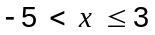
b Represent the inequality on a number line.
10 The nth term of a sequence is 7n – 3
Write down the first three terms of the sequence.
11 Factorise:
a 12a + 8b b xy – 2x c 2k² + 6k d 3pq² − 12p²r
12 Ranvir goes for a cycle ride. The distance–time graph shows her ride.
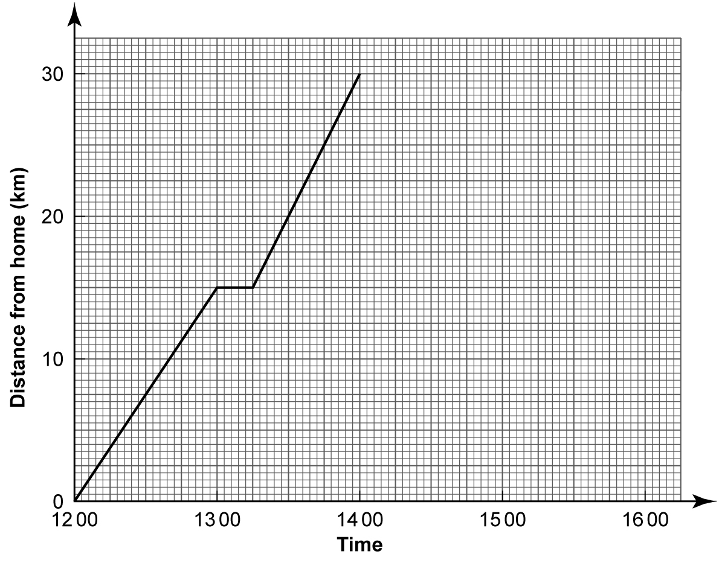
She sets off from home at 12 00 and has a flat tyre at 14 00.
During her ride she stops for a rest.
a i At what time does Ranvir stop for a rest?
ii At what speed does she travel before her rest?
It takes Ranvir 30 minutes to repair the flat tyre. She then cycles home at 20 km per hour.
b Copy the distance–time graph and complete it to show Ranvir’s journey home.
13 Remove the brackets and then simplify:
a 3(5x + y) + 2(3y − 2x) b 5(2m + 3) − 3(4 − m)
14 Here are the first five numbers of a sequence:
3, 9, 15, 21, 27
a Write down the next two numbers in the sequence.
b Write down, in words, the term-to-term rule to continue this sequence.
c Write down an expression for the nth term of this sequence.
d What will the 20th term of the sequence be?
15 Solve the inequality 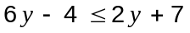
16 Solve the following equations:
a 4(a + 3) = 6(a − 1) b 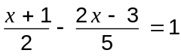
17 Starting with x = 4, use a trial and improvement method to find, correct to one decimal
place, a solution to the equation x³ + x = 84
Show all your working.
18 a Copy and complete the table for y = x² − 2x − 2
x | −2 | −1 | 0 | 1 | 2 | 3 | 4
y | 6 |  | −2 |  |  | 1
b Draw x- and y-axes with the x-axis from −2 to 4 and the y-axis from −4 to 6.
On the axes, draw the graph of y = x² − 2x − 2 for values of x from −2 to 4.
c Write down the equation of the line of symmetry of the graph.
d Write down the coordinates of the minimum point on the graph.
e Use your graph find the values of x when y = 0.

